Objectives:

* Tkinter GUI Design

**There are four projects each worth 25%**

**Project #1**

Type in the code below to create the list box.

**#1 print screen the code with the output below here.**

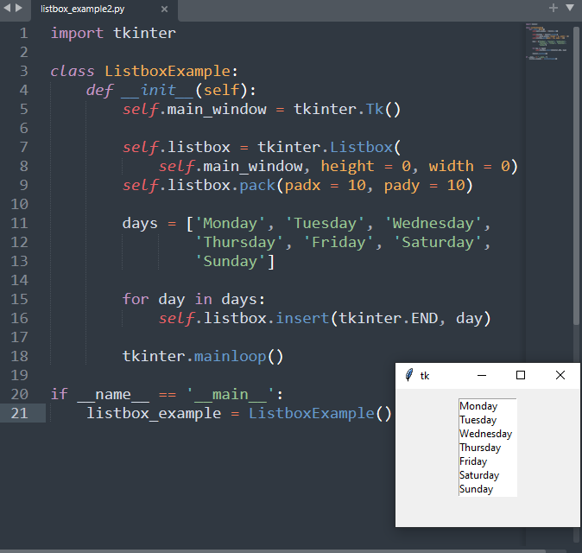

**Project #2**

Type in the code below to create the list box.

**#2 print screen the code with the output below here.**

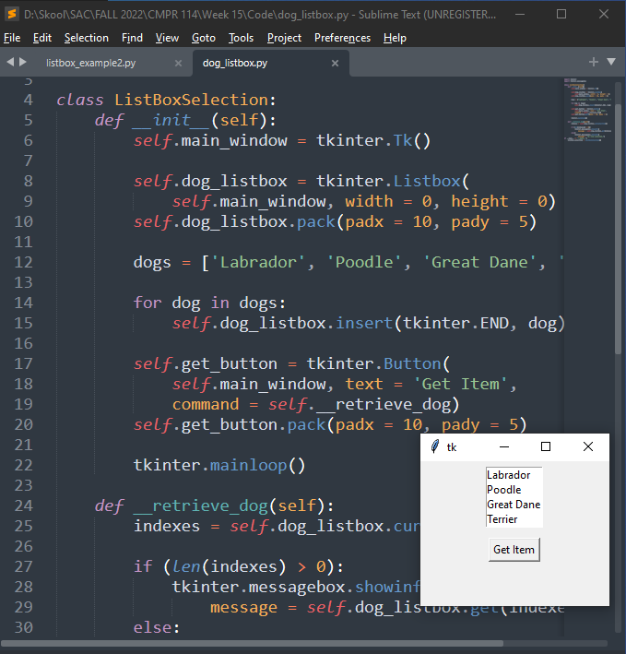

**Project #3**

Type in the code below to create the horizontal scroll bar.

**#3 print screen the code with the output below here.**

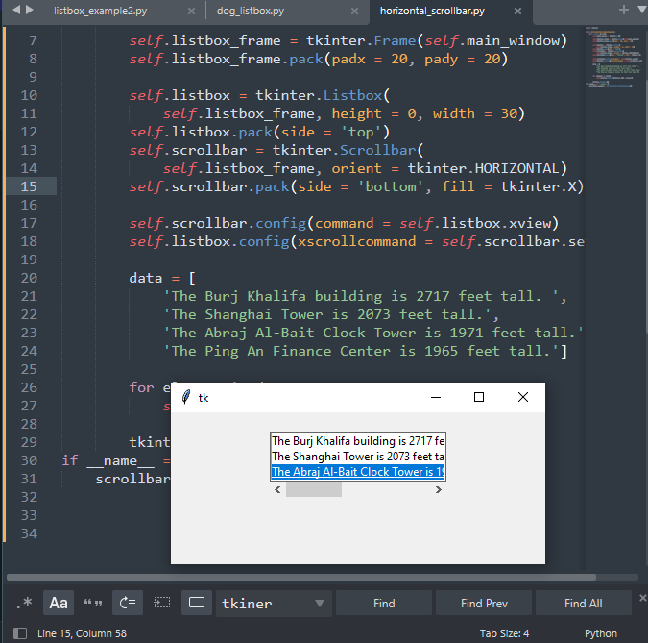

**Project #4**

Using Tkinter, complete the following program below

**#4 print screen the code with the output below here.**

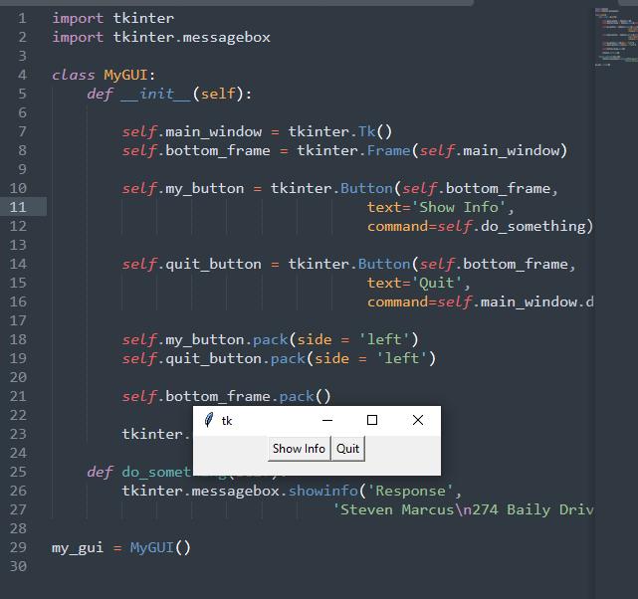

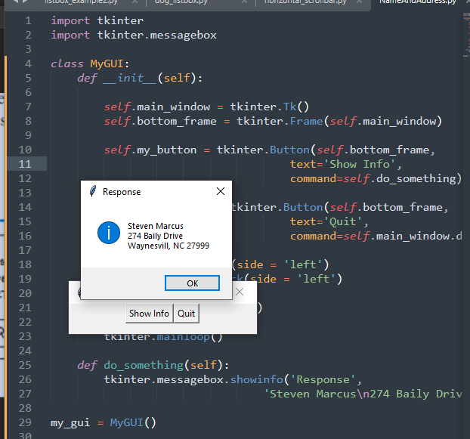

**Submit this document to Module 15 Homework**